“AUGMENTED REALITY GAME”

END TERM REPORT

Submitted by

|  |  |  |  |
| --- | --- | --- | --- |
| NAME | SECTION | ROLL. NO. | REGD. NUMBER |
| Vivek Kumar | K18HV | 49 | 11803833 |
| Amit Kumar Maurya | K18HV | 61 | 11803830 |
| Vikas Sharma | K18HV | 57 | 11814879 |
| Shrey Khandelwal | K18HV | 55 | 11803832 |



**Department of Intelligent System**

**School of Computer Science Engineering**

**LOVELY PROFESSIONAL UNIVERSITY, Jalandhar**

DECLARATION

This is to declare that this report has been written by us. No part of the report is copied from other sources. All information included from other sources have been duly acknowledged. We aver that if any part of the report is found to be copied, we are shall take full responsibility for it.

**Vivek Kumar**

**Regd. No. 11803833**

**Roll No. 49**

**Amit Kumar Maurya**

**Regd. No. 11803830**

**Roll No. 61**

**Vikas Sharma**

**Regd. No. 11814879**

**Roll No. 57**

**Shrey Khandelwal**

**Regd. No. 11803832**

**Roll No. 55**

**PLACE:** LOVELY PROFESSIONAL UNIVERSITY

**DATE:** 09/04/2020

TABLE OF CONTENT

1. **Introduction…………………………………………………………………......**
   1. **What is augmented reality? ……………………………………………….**
   2. **Difference b/w virtual reality & augmented reality………………………**
   3. **Technologies used in augmented reality…………………………………..**
   4. **Software and algorithms……………………………………………...........**
2. **Application of augmented reality………………………………………………**
3. **Advantages and disadvantages…………………………………………………**
   1. **Advantages of augmented reality………………………………………….**
   2. **Disadvantages of augmented reality…………………………....................**
4. **Work division among student…………………………………………………..**

BONAFIDE CERTIFICATE

Certified that this project report “ AUGMENTED REALITY GAME”is the bonafide work of “Vivek Kumar, Amit Kumar Mourya, Vikas Sharma and Shrey Khandelwal, ” who carried out the project work under my supervision.

Signature of the Supervisor

Dipen Saini

INTRODUCTION

**WHAT IS AUGMENTED REALITY?**

Augmented reality (AR) is an interactive experience of a real-world environment where the objects that reside in the real world are enhanced by computer-generated perceptual information, sometimes across multiple sensory modalities, including visual, auditory, haptic, somatosensory and olfactory.

AR can be defined as a system that fulfills three basic features: a combination of real and virtual worlds, real-time interaction, and accurate 3D registration of virtual and real objects. The overlaid sensory information can be constructive (i.e. additive to the natural environment), or destructive (i.e. masking of the natural environment). This experience is seamlessly interwoven with the physical world such that it is perceived as an immersive aspect of the real environment.

In this way, augmented reality alters one's ongoing perception of a real-world environment, whereas virtual reality completely replaces the user's real-world environment with a simulated one. Augmented reality is related to two largely synonymous terms: mixed reality and computer-mediated reality.

**DIFFERENCE B/W VIRTUAL REALITY & AUGMENTED REALITY**

In Virtual Reality (VR), the users' perception of reality is completely based on virtual information. In Augmented Reality (AR) the user is provided with additional computer generated information that enhances their perception of reality.

For example, in architecture, VR can be used to create a walk-through simulation of the inside of a new building; and AR can be used to show a building's structures and systems super-imposed on a real-life view. Another example is through the use of utility applications.

Augmented Reality (AR) differs from Virtual Reality (VR) in the sense that in AR part of the surrounding environment is actually 'real' and just adding layers of virtual objects to the real environment. On the other hand, in VR the surrounding environment is completely virtual. A demonstration of how AR layers objects onto the real world can be seen with augmented reality games.

Walla Me is an augmented reality game application that allows users to hide messages in real environments, utilizing geolocation technology in order to enable users to hide messages wherever they may wish in the world.

It can also be used to demo what products may look like in an environment for customers, as demonstrated by companies such as Mountain Equipment Co-op or Lowe's who use augmented reality to allow customers to preview what their products might look like at home through the use of 3D models.

**TECHNOLOGIES USED IN AUGMENTED REALITY**

* **HARDWARE:** Hardware components for augmented reality are: a processor, display, sensors and input devices. Modern mobile computing devices like smartphones and tablet computers contain these elements, which often include a camera and Microelectromechanical systems (MEMS) sensors such as an accelerometer, GPS, and solid state compass, making them suitable AR platforms.
* **DISPLAY:** Various technologies are used in augmented reality rendering, including optical projection systems, monitors, handheld devices, and display systems, which are worn on the human body.
* **EYEGLASSES:** AR displays can be rendered on devices resembling eyeglasses. Versions include eyewear that employs cameras to intercept the real world view and re-display its augmented view through the eyepieces and devices in which the AR imagery is projected through or reflected off the surfaces of the eyewear lens pieces.
* **HUD:** A head-up display (HUD) is a transparent display that presents data without requiring users to look away from their usual viewpoints. A precursor technology to augmented reality, heads-up displays were first developed for pilots in the 1950s, projecting simple flight data into their line of sight, thereby enabling them to keep their "heads up" and not look down at the instruments.
* **CONTACT LENSES:** In Augmented Reality, the distinction is made between two distinct modes of tracking, known as marker and marker less. Markers are visual cues which trigger the display of the virtual information. A piece of paper with some distinct geometries can be used. The camera recognizes the geometries by identifying specific points in the drawing. Markerless tracking, also called instant tracking, does not use markers. Instead, the user positions the object in the camera view preferably in a horizontal plane.
* **VIRTUAL RETINAL DISPLAY:** A virtual retinal display (VRD) is a personal display device under development at the University of Washington's Human Interface Technology Laboratory under Dr. Thomas A. Furness III. With this technology, a display is scanned directly onto the retina of a viewer's eye. This results in bright images with high resolution and high contrast. The viewer sees what appears to be a conventional display floating in space.
* **EYE TAP:** The Eye Tap (also known as Generation-2 Glass) captures rays of light that would otherwise pass through the center of the lens of the wearer's eye, and substitutes synthetic computer-controlled light for each ray of real light.
* **HANDHELD:** A Handheld display employs a small display that fits in a user's hand. All handheld AR solutions to date opt for video see-through. Initially handheld AR employed fiducial markers, and later GPS units and MEMS sensors such as digital compasses and six degrees of freedom accelerometer–gyroscope. Today Simultaneous localization and mapping marker less trackers such as PTAM are starting to come into use. Handheld display AR promises to be the first commercial success for AR technologies
* **SPATIAL:** Spatial augmented reality (SAR) augments real-world objects and scenes, without the use of special displays such as monitors, head-mounted displays or hand-held devices. SAR makes use of digital projectors to display graphical information onto physical objects. The key difference in SAR is that the display is separated from the users of the system. Since the displays are not associated with each user, SAR scales naturally up to groups of users, allowing for collocated collaboration between users.
* **TRACKING:** Modern mobile augmented-reality systems use one or more of the following motion tracking technologies: digital cameras and/or other optical sensors, accelerometers, GPS, gyroscopes, solid state compasses, Radio-frequency identification (RFID). These technologies offer varying levels of accuracy and precision. The most important is the position and orientation of the user's head. Tracking the user's hand(s) or a handheld input device can provide a 6DOF interaction technique.
* **INPUT:** devices: Techniques include speech recognition systems that translate a user's spoken words into computer instructions, and gesture recognition systems that interpret a user's body movements by visual detection or from sensors embedded in a peripheral device such as a wand, stylus, pointer, glove or other body wear. Products which are trying to serve as a controller of AR headsets include Wave by Seebright Inc. and Nimble by Intugine Technologies.
* **COMPUTER:** The computer analyzes the sensed visual and other data to synthesize and position augmentations. Computers are responsible for the graphics that go with augmented reality. Augmented reality uses a computer-generated image which has a striking effect on the way the real world is shown. With the improvement of technology and computers, augmented reality is going to lead to a drastic change on ones perspective of the real world. According to Time, in about 15–20 years it is predicted that augmented reality and virtual reality are going to become the primary use for computer interactions.
* **PROJECTOR:** Projectors can also be used to display AR contents. The projector can throw a virtual object on a projection screen and the viewer can interact with this virtual object. Projection surfaces can be many objects such as walls or glass panes.

**SOFTWARE AND ALGORITHMS**

A key measure of AR systems is how realistically they integrate augmentations with the real world. The software must derive real world coordinates, independent of camera, and camera images. That process is called image registration, and uses different methods of computer vision, mostly related to video tracking. Many computer vision methods of augmented reality are inherited from visual odometry. An augogram is a computer generated image that is used to create AR. Augography is the science and software practice of making augograms for AR.

Usually those methods consist of two parts. The first stage is to detect interest points, fiducial markers or optical flow in the camera images. This step can use feature detection methods like corner detection, blob detection, edge detection or thresholding, and other image processing methods. The second stage restores a real world coordinate system from the data obtained in the first stage.

Some methods assume objects with known geometry (or fiducial markers) are present in the scene. In some of those cases the scene 3D structure should be calculated beforehand. If part of the scene is unknown simultaneous localization and mapping (SLAM) can map relative positions. If no information about scene geometry is available, structure from motion methods like bundle adjustment are used.

Mathematical methods used in the second stage include: projective (epipolar) geometry, geometric algebra, rotation representation with exponential map, kalman and particle filters, nonlinear optimization, robust statistics.

Augmented Reality Markup Language (ARML) is a data standard developed within the Open Geospatial Consortium (OGC), which consists of Extensible Markup Language (XML) grammar to describe the location and appearance of virtual objects in the scene, as well as ECMAScript bindings to allow dynamic access to properties of virtual objects.

To enable rapid development of augmented reality applications, some software development kits (SDKs) have emerged.

APPLICATION OF AUGMENTED REALITY

**Possible applications are:**

* **ARCHAEOLOGY**
* **ARCHITECTURE**
* **URBAN DESIGN & PLANNING**
* **STEM EDUCATION**
* **INDUSTRIAL MANUFACTURING**
* **COMMERCE**
* **LITERATURE**
* **VISUAL ART**
* **EMERGENCY MANAGEMENT/SEARCH AND RESCUE**
* **SOCIAL INTERACTION**
* **VIDEO GAMES**
* **INDUSTRIAL DESIGN**
* **HEALTHCARE PLANNING, PRACTICE AND EDUCATION**
* **SPATIAL IMMERSION AND INTERACTION**
* **FLIGHT TRAINING**
* **MILITARY**
* **NAVIGATION**
* **WORKPLACE**
* **BROADCAST AND LIVE EVENTS**
* **TOURISM AND SIGHTSEEING**
* **TRANSLATION**
* **MUSIC**
* **SNAPCHAT**

Advantages and disadvantages

**ADVANTAGES OF AUGMENTED REALITY:**

* With the help of augmented reality, life’s activities become easy and fun.
* One of the biggest advantage of augmented reality is its use in education field. With the implementation of augmented reality into education, students’ interaction and engagement in study increases. It helps to nurture learning process and increase student participation in classes. Thus, enriched way of learning.
* Augmented application like LookTel recognizer, Qualcomm helps intellectually disabled workers in their day to day activities and make their life easy.
* With the help of Augmented reality, individuals are able to access more relevant information according to their need and in a very less time.
* Home appliances become smart with the integration of Augmented reality. For example, refrigerator could write and tell shopping list for users.
* Video games experience is improved as it enriches virtual visualization experience of users. Real life example of video game that implement augmented reality is POKEMON GO.
* It helps in efficient diagnosis of disease and made patient’s life safer. Due to implementation of augmented reality in medical industry, physicians are able to detect disease at early stage.

**DISADVANTAGES OF AUGMENTED REALITY:**

* Though it provides numerous benefits to user and organizations, but it also associated some disadvantages that should be eliminated.
* There are many security and privacy issues in implementing augmented reality applications. Considering the fact that open architecture of the augmented reality applications is more vulnerable to cyber-attacks and threats.
* Implementation of augmented reality and hardware and software implementation is much costly.
* With the use of augmented reality, participation in real world is restricted in individual’s life.
* Individual’s perception is narrowed-down with the capabilities of augmented reality.
* With the continue usage of augmented reality applications can effect on human health and may cause low eyesight.
* Use of augmented reality can diminish real world reality.

Maze GAME

COMBINATION AUGMENTED REALITY AND ARTIFICIAL INTELLEGENCE

This game is based on primitive game that we used to play in our childhood. We had to find our way out in these mazes and we use many approaches such starting from the end or tracing back when necessary. In this game we are finding our way out by tracing the lines and it could work on any maze that is given to us.

Our problem was to extract lines from the page that we show on camera and process that image live and try to find our possible way out.

SCREENSHOTS

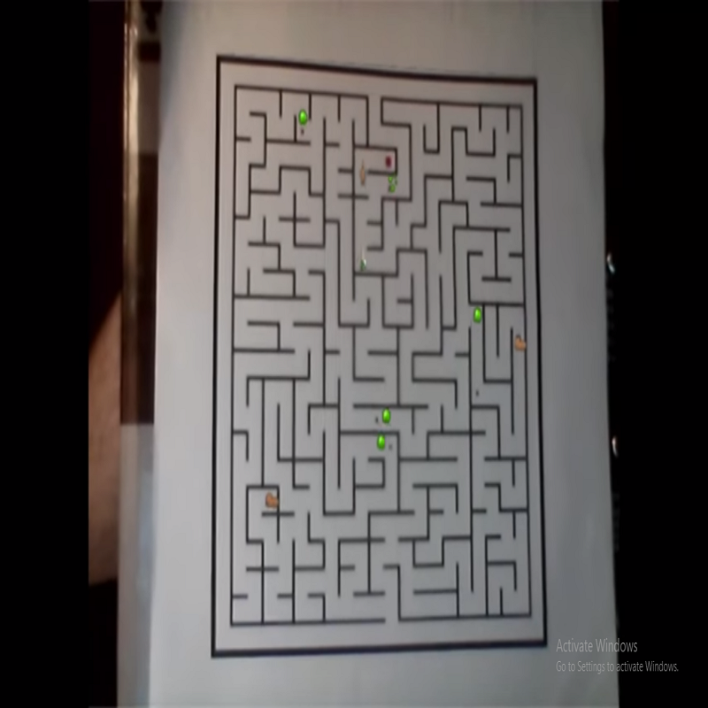

WORK DIVISION AMONG STUDENTS

**VIVEK KUMAR**

He was responsible for development of written report and 3 modules which are camera, build the maze and game.

**AMIT KUMAR MAURYA**

He was responsible for development of main frame idea and working the project. Also contributed in helper, image parsing module.

**VIKAS SHARMA AND SHREY KHANDELWAL**

They helped a lot in terms of ideas and actively contributed in test and maze solver module.